**CRM Application for Jewel Management**

**COLLEGE : KG COLLEGE OF ARTS AND SCIENCE**

**TEAM ID : NM2025TMID23751 TEAM SIZE : 4**

**TEAM MEMBERS DETAILS:**

TEAM LEADER : ROSHAN KUMAR R EMAIL : 2326ka41@kgcas.com

TEAM MEMBER : RUBIKA S

EMAIL : 2326ka42@kgcas.com

TEAM MEMBER : SABTHAMI S EMAIL : 2326ka43@kgcas.com

TEAM MEMBER : SAKTHIDASAN N

EMAIL : 2326ka44@kgcas.com

# 1.INTRODUCTION

**1.1 Project Overview:**

This project involves the development of a CRM-based Jewel Management System using Salesforce. It streamlines operations like inventory tracking, price updates, billing, and

customer management for a jewellery business. The project leverages Salesforce Lightning Platform to design custom objects, automate processes using Flows, and generate actionable insights via dashboards and reports.

**1.2 Purpose:**

The purpose is to replace manual processes with an automated, cloud-based Salesforce CRM that enables real-time stock updates, dynamic pricing, customer billing, and order tracking. The system enhances customer experience, operational accuracy, and business decision-making.

The purpose of this project is to design and implement a Salesforce-based CRM solution specifically for jewel businesses to:

* Centralize customer information and communication.

* Track and manage jewellery inventory (gold and silver).

* Enable personalized marketing and offers.

* Facilitate efficient order processing and billing.

* Improve customer retention through engagement automation.

* Generate detailed reports on sales, trends, and staff performance.

# 2. IDEATION PHASE

**2.1 Problem Statement:**

Traditional jewellery shops face problems like manual stock maintenance, lack of customer records, and inefficiencies in pricing and billing. There's also no integrated view of customer interactions. This leads to errors, delayed decision-making, and customer

dissatisfaction.

Many small to mid-sized jewellery retailers struggle with managing customer relationships, tracking sales, handling special orders, and maintaining inventory. Current manual systems or generic software often fall short of addressing the industry's unique needs.

**2.2 Empathy Map Canvas:**

**Think & Feel**

* “Are we missing out on leads because we’re not following up?”

* “I need to know who our high-value customers are.”

**Hear**

* “The customer wasn’t happy with the delay in their custom order.”

* “Can we send reminders for anniversaries and birthdays?”

**See**

* Registers with scribbled orders.

* Multiple Excel sheets for billing and inventory.

**Say & Do**

* “Call them about the pendant order tomorrow.”

* “Print out last year’s top customers list.”

**Pain**

* Losing customers due to lack of follow-up.

* No real-time inventory tracking.

**Gain**

* Higher customer satisfaction.

* More repeat purchases via automation.

**2.3 Brainstorming:**

The brainstorming phase focused on collecting diverse ideas from stakeholders—including jewel store owners, sales representatives, developers, and end-users—to define potential solutions and functionalities required in the CRM application. This collaborative ideation process aimed to understand the operational bottlenecks in the jewelry business and how Salesforce’s cloud ecosystem could streamline them.

Ideas collected during brainstorming:

* Use of custom objects for Items, Billing, Orders, and Customers.
* Automate stock management with flows.
* Dashboard for daily performance insights.
* Notifications for low inventory.
* Implement record-triggered and scheduled flows.
* Introduce validation rules to prevent data inconsistencies.
* Plan separate dashboards for different roles (sales, inventory, admin).

1. **Requirement Analysis:** 
   1. **Customer Journey Map:**

The customer journey map outlines the stages a customer experiences, from the first interaction to post-purchase engagement. It helps identify gaps and opportunities where the CRM can automate and enhance customer experience.

**Awareness Stage**

* + - * Customer browses website or social media.

* + - * CRM captures leads using Web-to-Lead forms.

**Consideration Stage**

* + - * Customer visits the store or requests a catalog.

* + - * Salesforce auto-assigns a sales representative.

* + - * Email/SMS with product recommendations is triggered.

**Purchase Stage**

* + - * Customer places an order (in-store or online).

* + - * CRM logs order and creates a sales opportunity.

* + - * Invoice is generated using built-in templates.

**Delivery Stage**

* + - * Customer receives order.

* + - * CRM sends order tracking notifications and confirmations.

**Post-Purchase Stage**

* + - * Customer receives feedback form.

* + - * Loyalty points are updated.

* + - * Follow-up reminders for anniversaries, birthdays, etc.

* 1. **Solution Requirements:**

Defines both the functional (what the system should do) and non-functional (how the system performs) needs to fulfill business goals.

* + - * Real-time item stock tracking
      * Dynamic pricing management
      * Billing with automated tax calculations
      * Comprehensive dashboards and reports
      * Data security and accessibility
      * Integration with communication tools (email/SMS)
      * Record ownership for audit and traceability

* 1. **Data Flow Diagrams:**

DFD illustrates how data moves between the system's components. This helps developers visualize dependencies and database interaction points.

**Main Entities & Data Flow Points:**

* + 1. Customer submits a product inquiry.

* + 1. Data flows to CRM Interface (Form or App).

* + 1. CRM creates or updates Customer Object.

* + 1. CRM logs sale and updates Sales Record.

* + 1. Inventory count is adjusted in the Inventory Object.

* + 1. Reports are updated to reflect real-time sales and stock.

* 1. **Technology Stack:**

Defines the tools and platforms used to develop, deploy, and manage the CRM system in Salesforce.

* + - * Platform: Salesforce Lightning Experience.
      * Logic: Apex Triggers, Validation Rules, Flow Builder.
      * UI: Lightning Tabs, Pages, Reports, Dashboards.
      * Database: Salesforce Standard & Custom Objects.
      * Integration: Email Templates, Scheduled Flows, Approval Processes.

# 4.PROJECT DESIGN

**4.1 Problem Solution Fit:**

**Problem:** Manual processes and lack of centralized tracking

**Solution:** Salesforce CRM system automating every major jewelry workflow

**4.2 Proposed Solution:**

**Five major custom objects:** Item__c, Price__c, Jewel_Customer__c, Customer_Order__c,

Billing__c

* Lightning app with navigation tabs
* Automated flows for inventory, billing, and notifications ● Dashboards visualizing sales, stock, and revenue performance

**4.3: Solution Architecture:**

**Objects and Relationships:**

* Jewel_Customer__c ↔ Customer_Order__c ↔ Billing__c ↔ Item__c ↔ Price__c
* Lookup and Master-Detail fields used to link records
* Formula fields for auto-calculations (e.g., total billing amount)
* Validation rules for quantity and price limits
* Record Types to distinguish Gold, Silver, and Diamond workflows

# 5. PROJECT PLANNING AND SCHEDULING

**5.1 Project Planning:**

The planning and scheduling phase involves defining the project's timeline, scope, team responsibilities, tools, and milestones. It ensures the project stays on track and aligns with business goals while delivering the CRM application in an efficient, scalable, and phased manner.

* Week 1: Requirement gathering, Usecase and ER Diagrams
* Week 2: Custom object creation, Page Layouts and Tab Setup
* Week 3: Flows and Automation Setup, Validation Rules
* Week 4: Reports and Dashboards, Testing and Review
* Week 5: Final Deployment, Documentation and User Training

1. **PROJECT DEVELOPMENT PHASE - SALESFORCE GUIDED**  **PROJECT**

The development phase is the backbone of the CRM application, where core functionalities were implemented using Salesforce’s declarative tools and programmatic capabilities. This phase was conducted in iterative sprints, following Agile methodology, and broken into several key activities.

* 1. **Developer Environment Setup:**

● Create Salesforce Developer Org via [developer.salesforce.com/signup](http://developer.salesforce.com/signup)

Fill the required information, verify email, set password, and access Salesforce Setup.

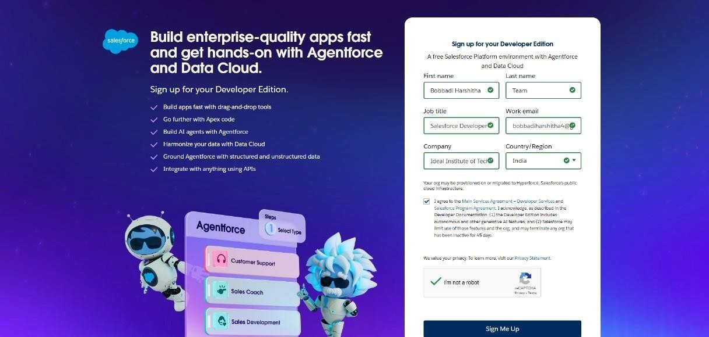

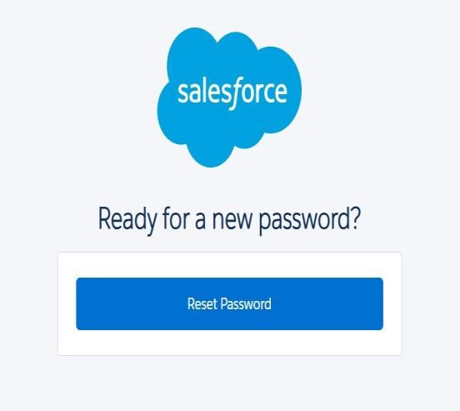

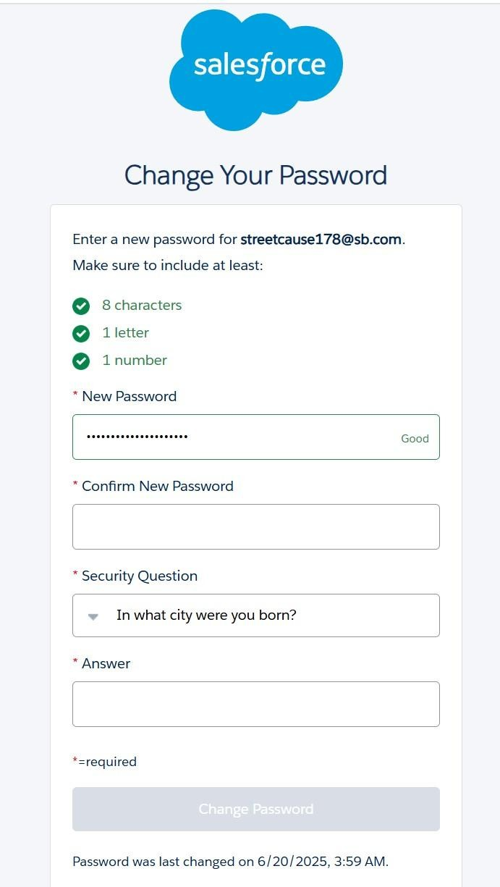

* 1. **Custom Object Creation:**

We create five main custom objects for Jewel Customer, Item, Customer Order,

Price, Billing.

1. **Jewel Customer**

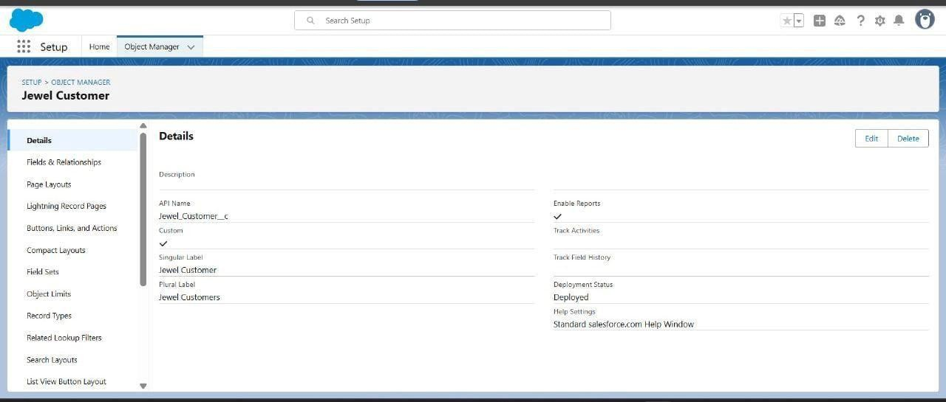

1. **Item**

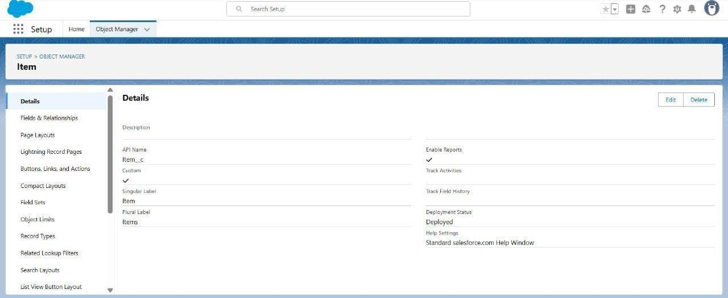

1. **Customer Order**

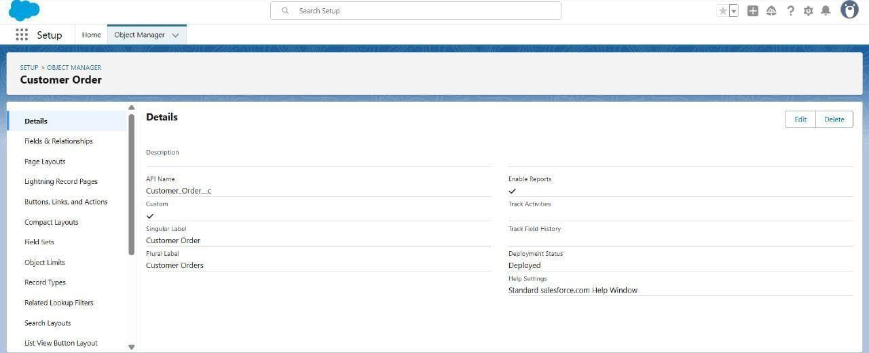

1. **Price**

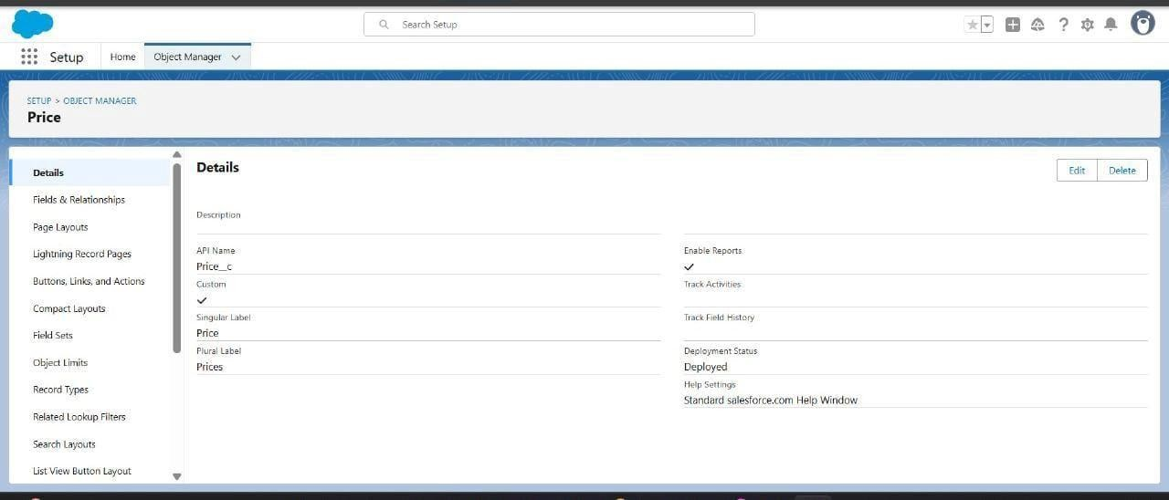

1. **Billing**

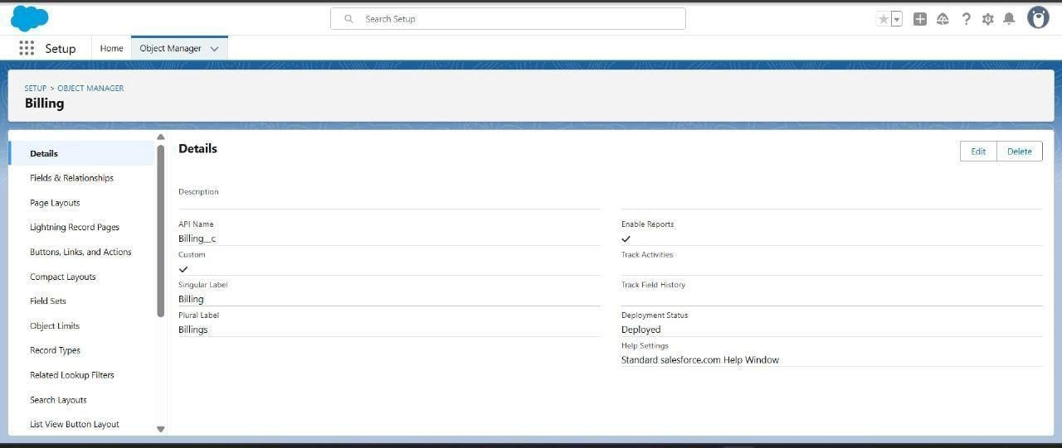

## 6.3 Creation of Tabs

We create five main custom tabs for Jewel Customer, Item, Customer Order, Price,

Billing.

1. **Jewel Customer**

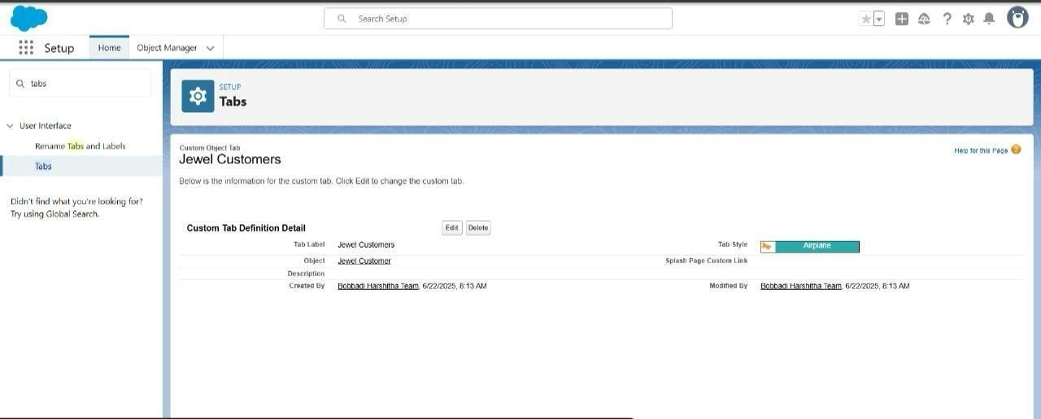

1. **Item**

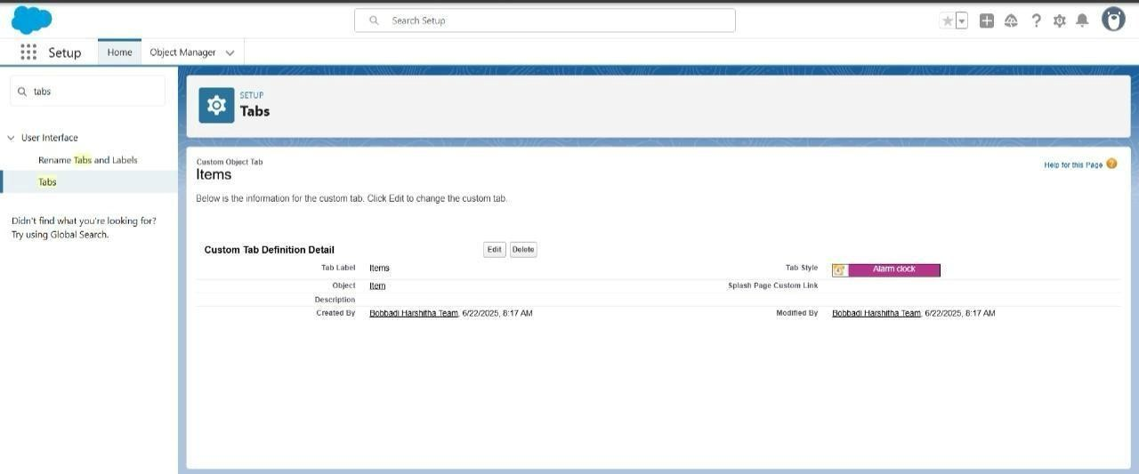

1. **Customer Order**

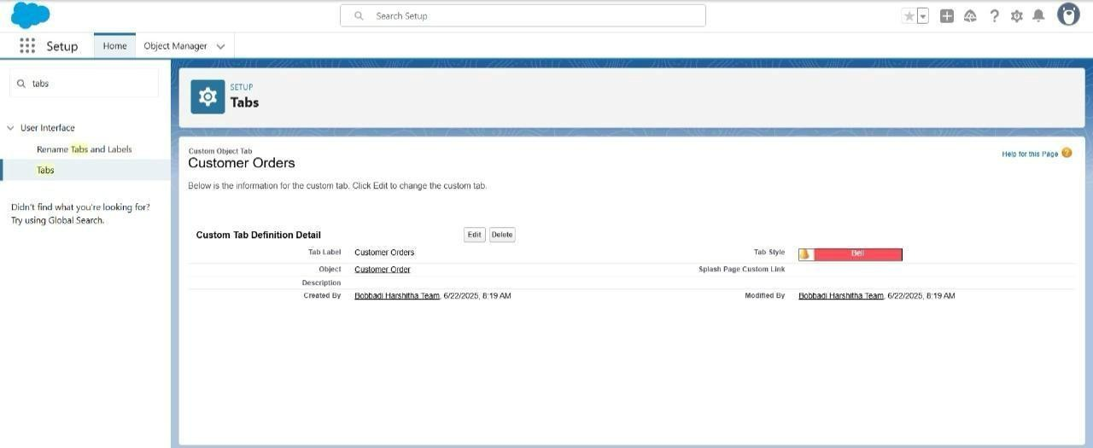

1. **Price**

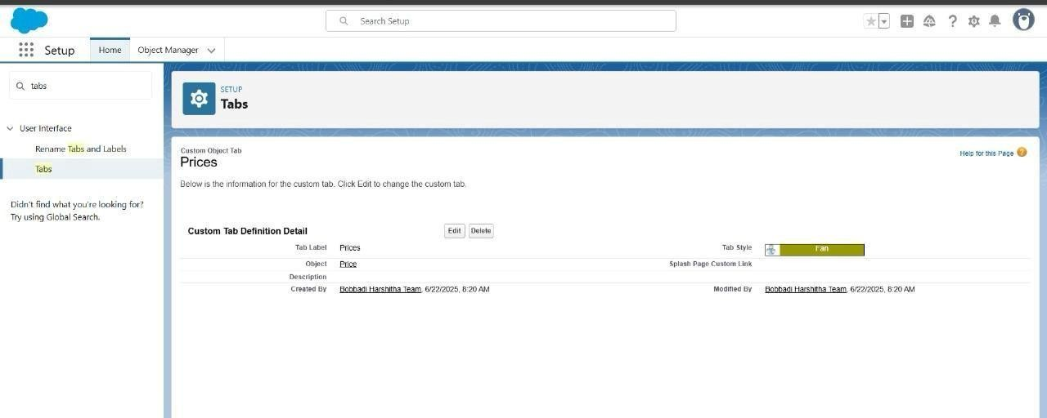

**5.Billing**

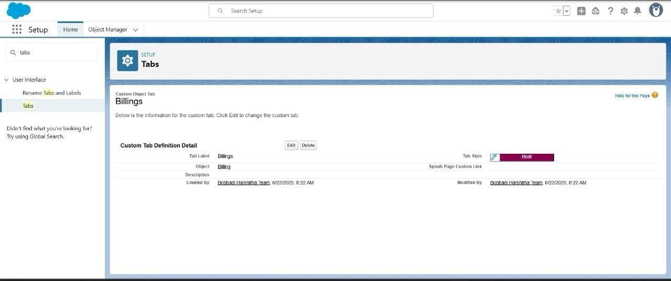

So we get the required all custom tabs as below

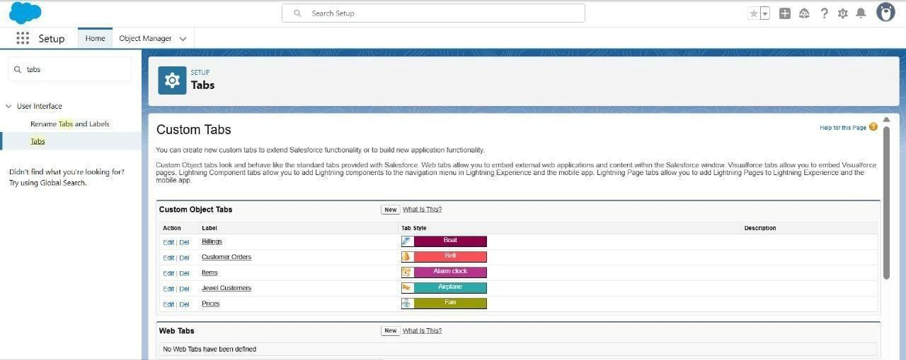

## 6.4 Creation of Lightning App

**App Name:** Jewelry Inventory System

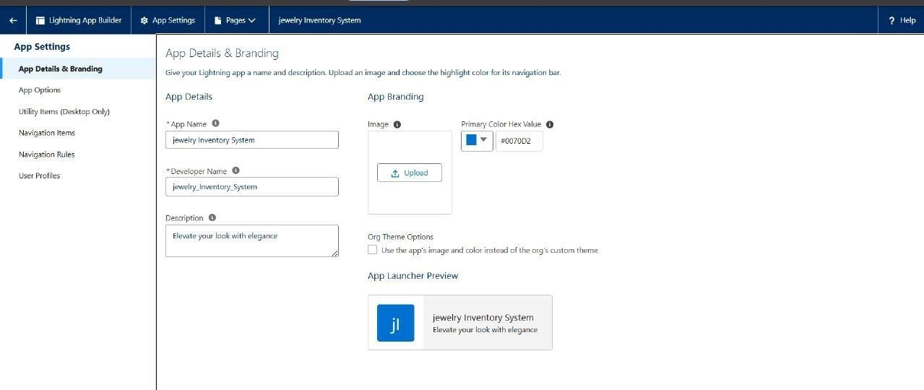

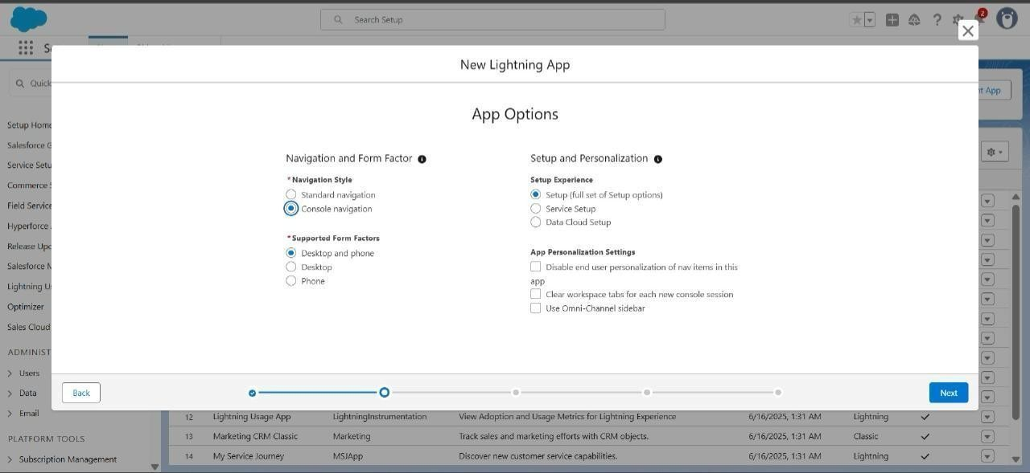

**Navigation Items**

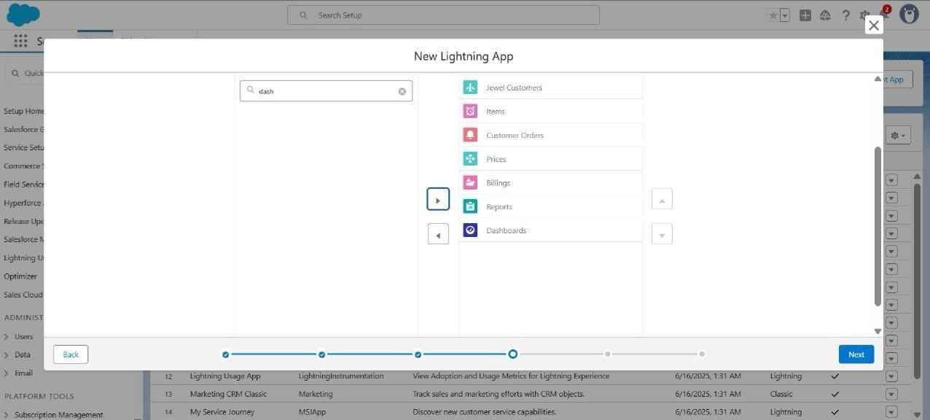

## 6.5 Creation of Fields

**1.Creating lookup relationship**

To Create a relationship between Jewel Customer & Customer Order Objects.

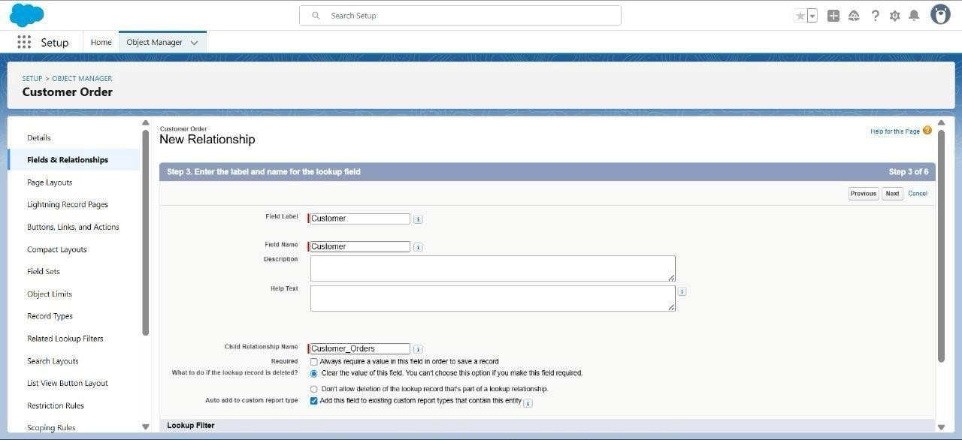

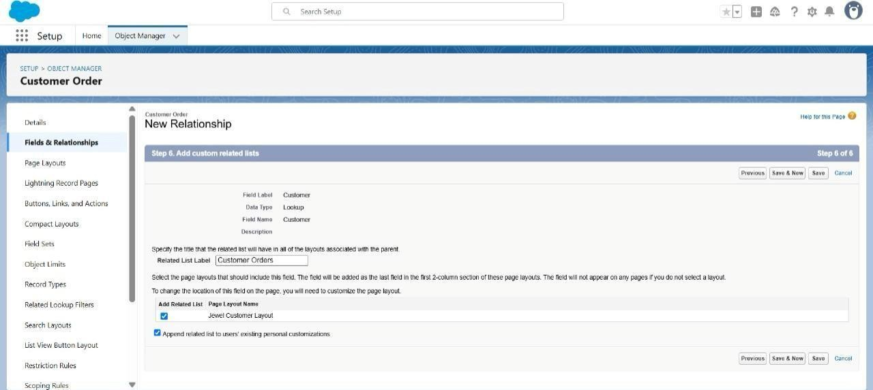

### 2. Creating a Master-Detail Relationship

Creating Master-Detail Relationship between Item & Customer Order Object.

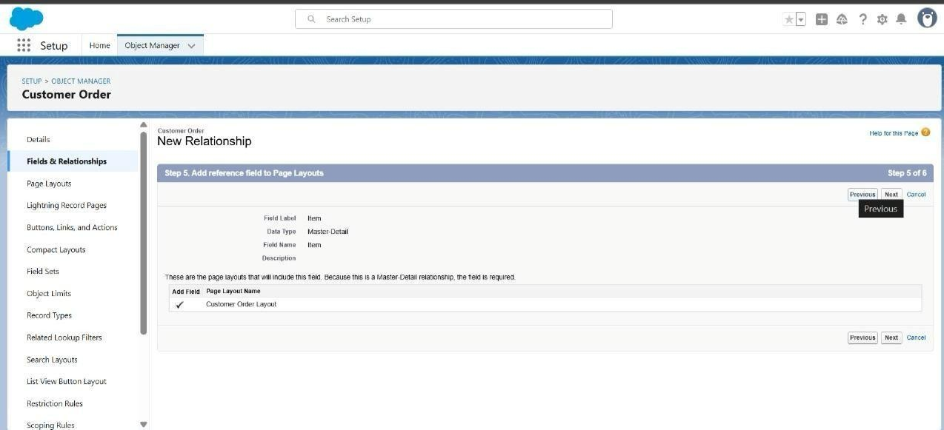

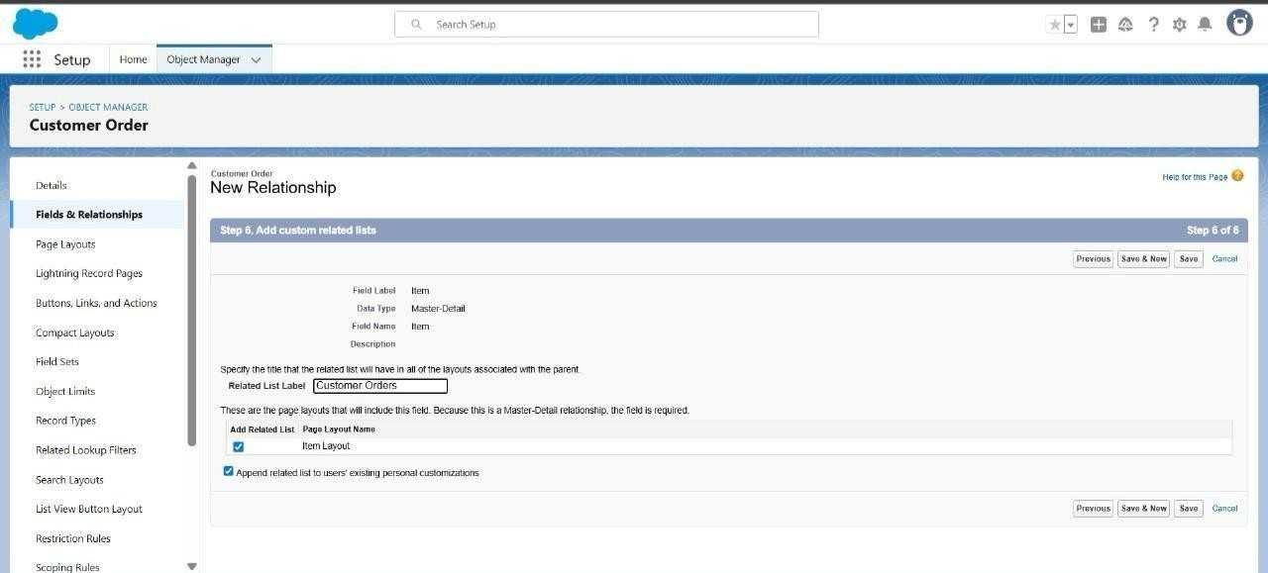

### 3. Creating Text Field in Jewel Customer Object

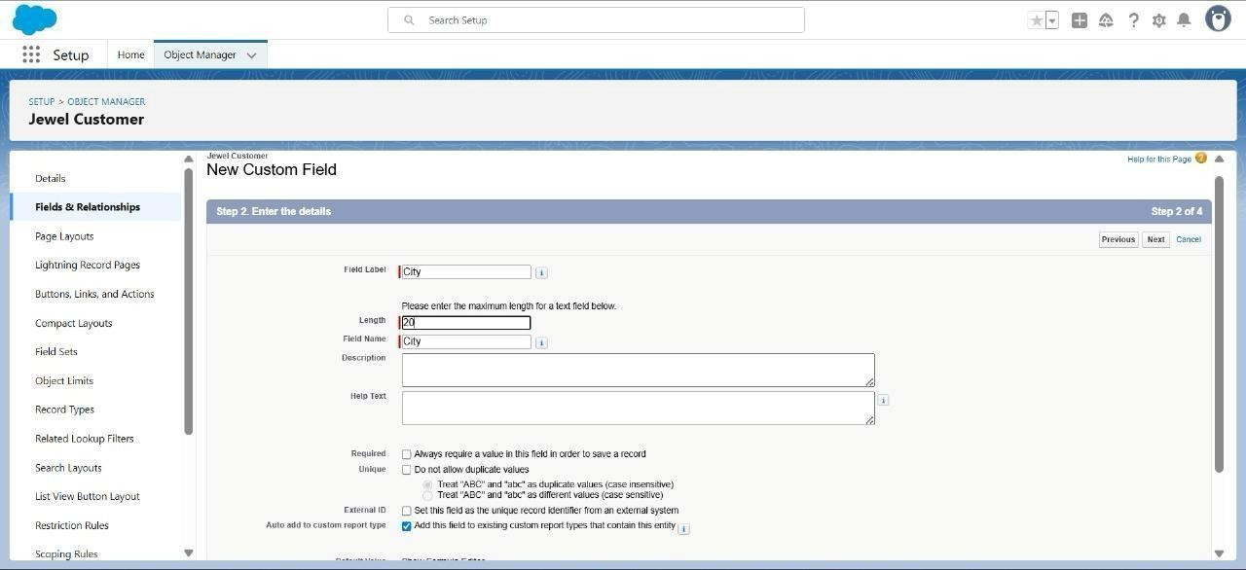

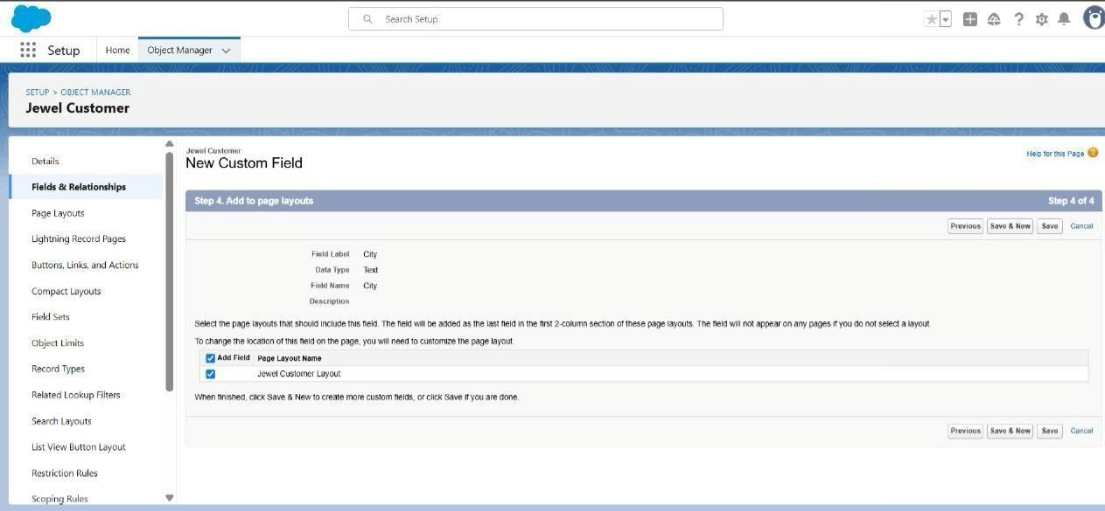

### 4. Creating the Phone field in object Jewel Customer

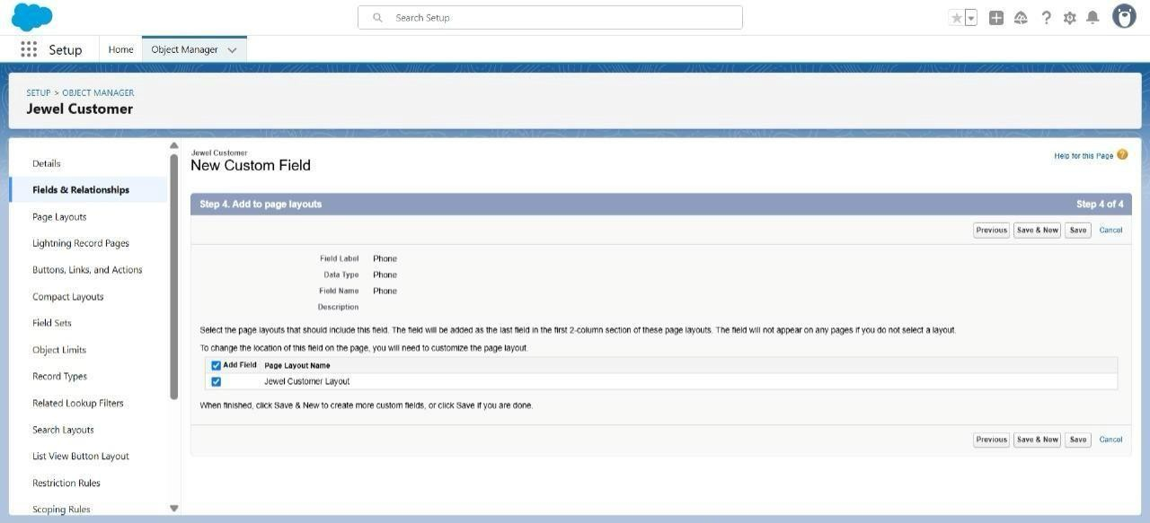

### 5. Creating the Email field in object Jewel Customer

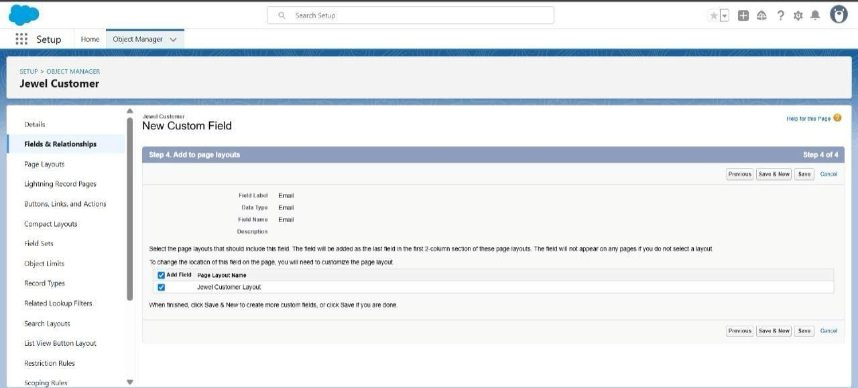

### 6. Creating the number field in Item object

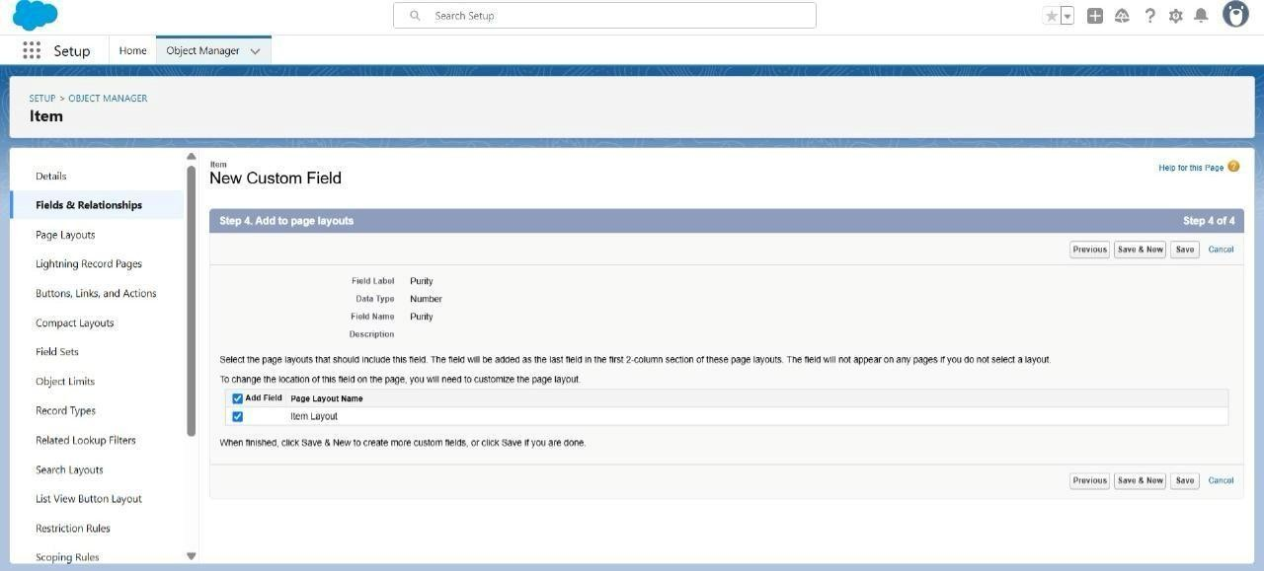

### 7. Creating Picklist Field in Item Object

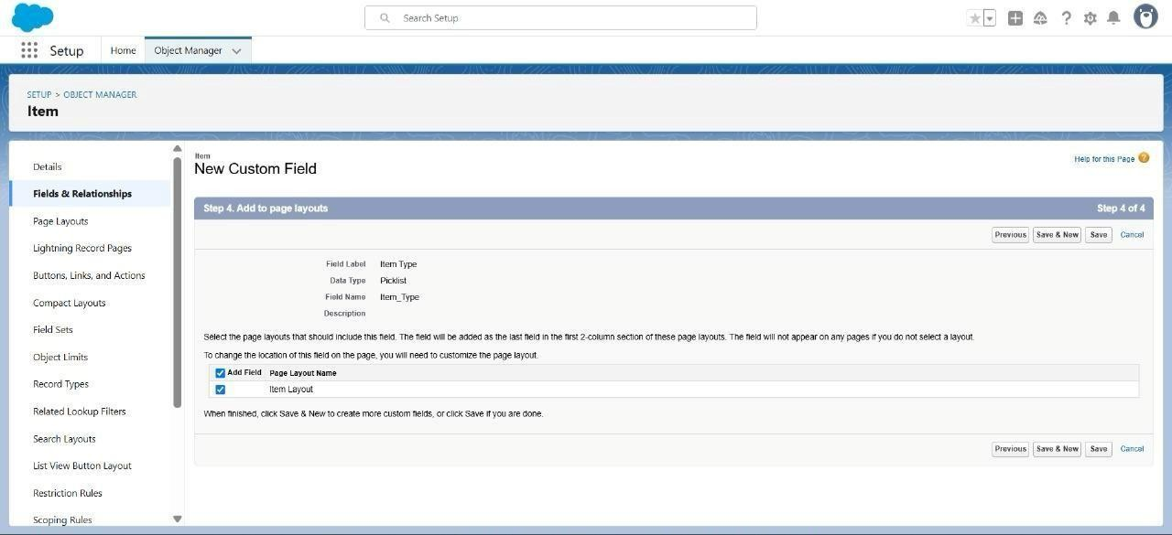

### 8. Creating Currency Field in Price Object

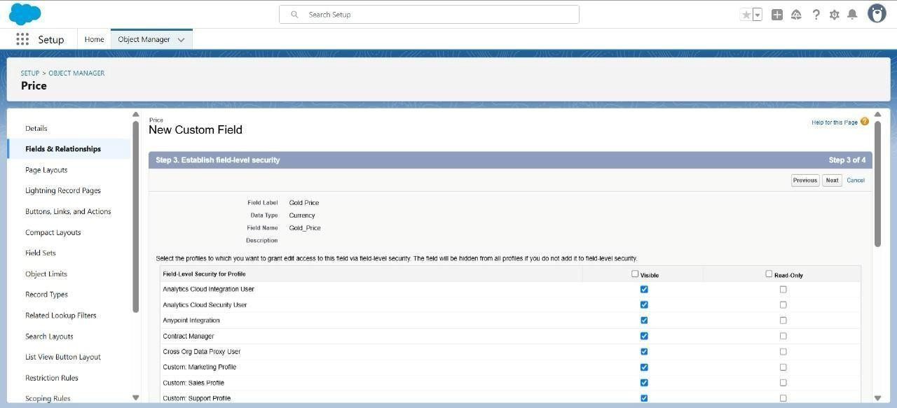

### 9. Creating Formula Field(Cross Object) in Item Object

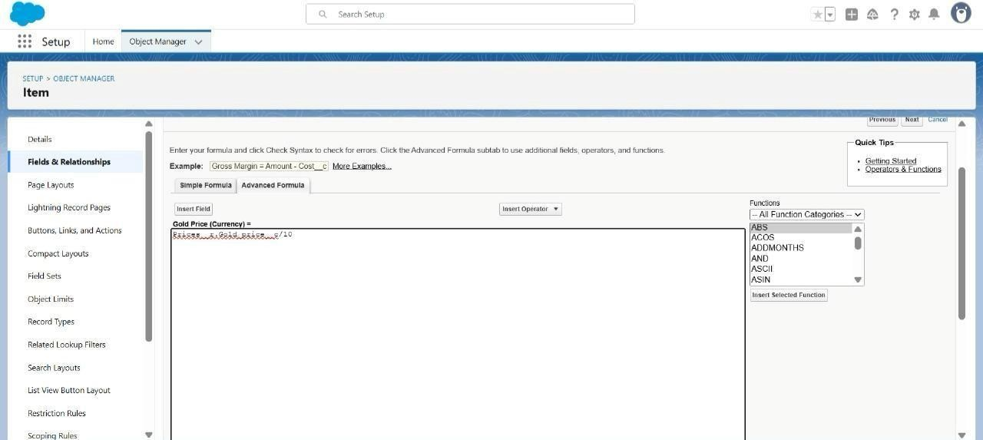

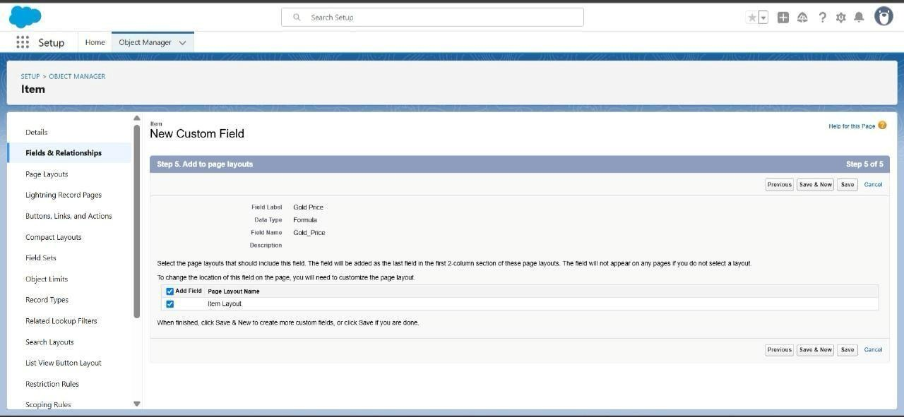

### 10. Creating Remaining Fields in Objects

Creating remaining fields in the objects

1.Jewel Customer : State, Street, Country, Zip/Postal code

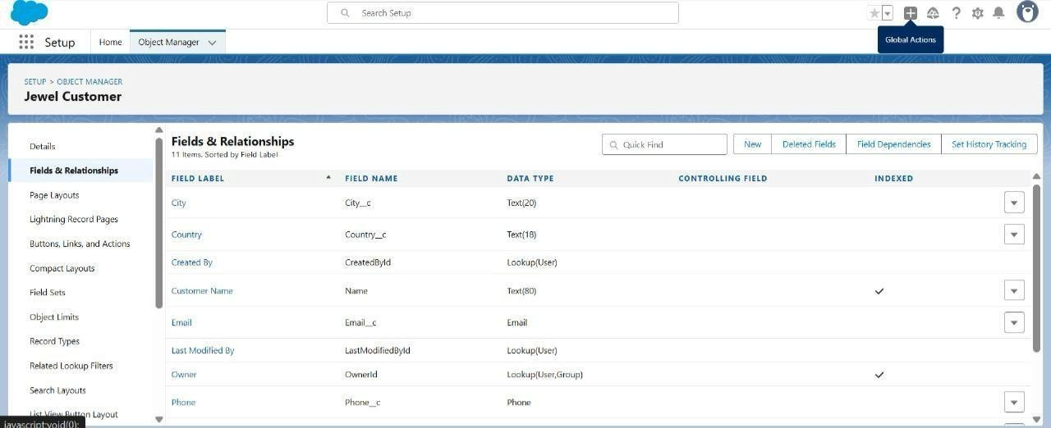

2.Price : Silver Price

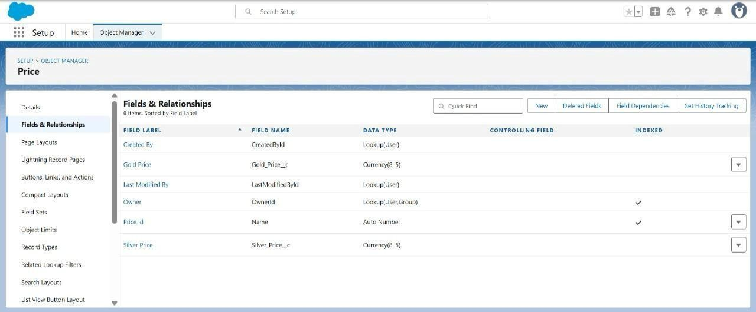

3.Item : Field Label-Customer Name, Ornament, Weight, Stone Weight, Percentage,

Stone/Other Price, Expected Days of Return, Priority, Silver Price, Purity Gold Price, Total weights, Amount, KDM, Making Charges.

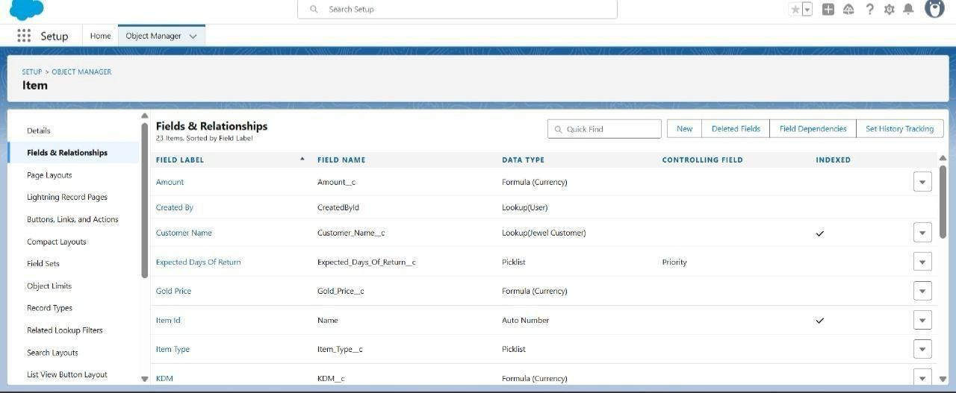

4.Customer Order: Order Status

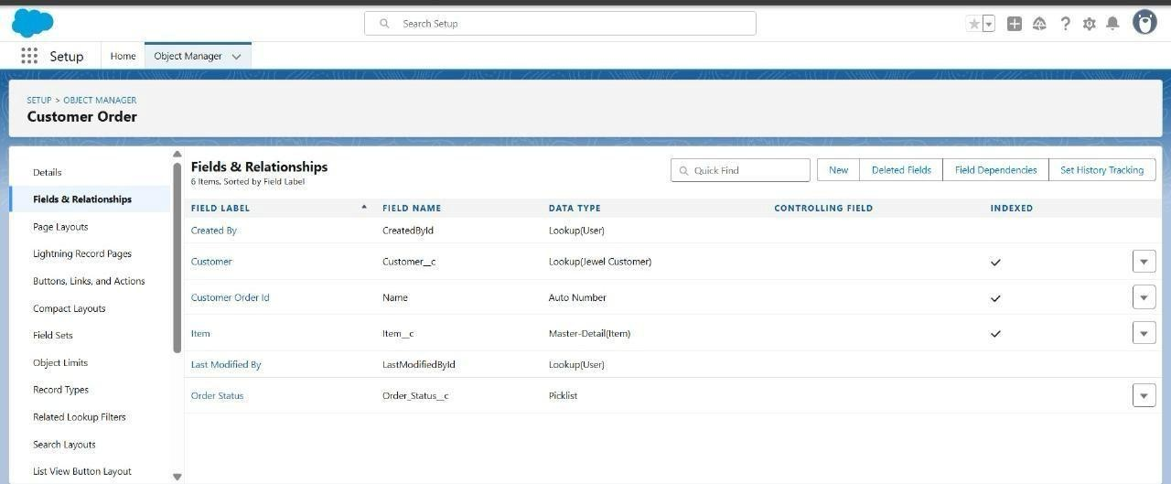

5.Billing: Field Label-Item, Ornament, Stone Weight, Weight, Amount, Gold/Silver Price, KDM Charge, Making Charges,Stone/Other Price, Total Amount.

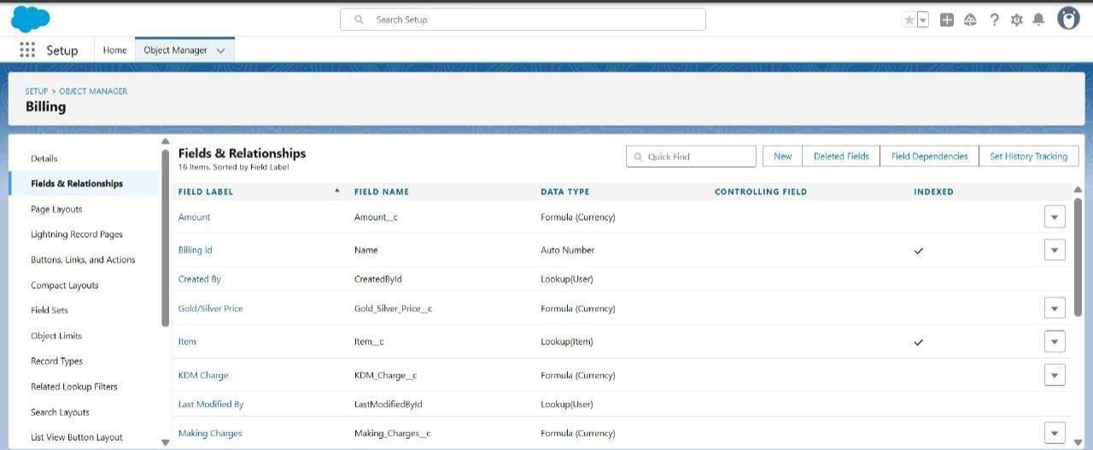

1. **Creation of Schema Builder**

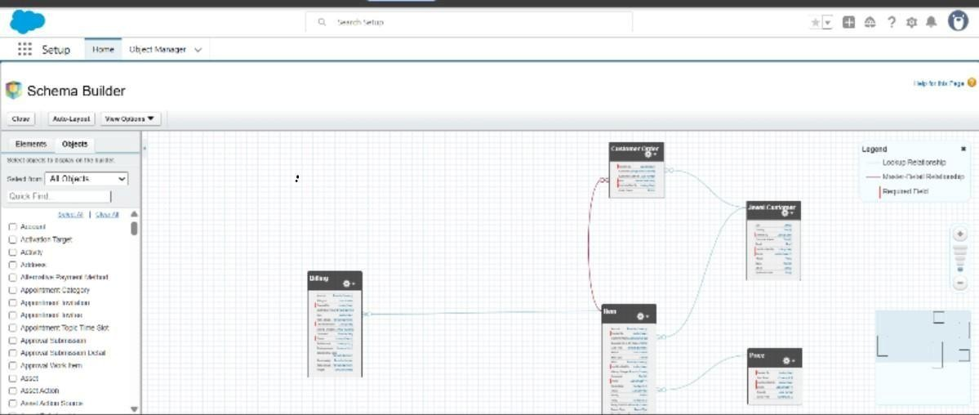

1. **Creation of Field Dependencies**

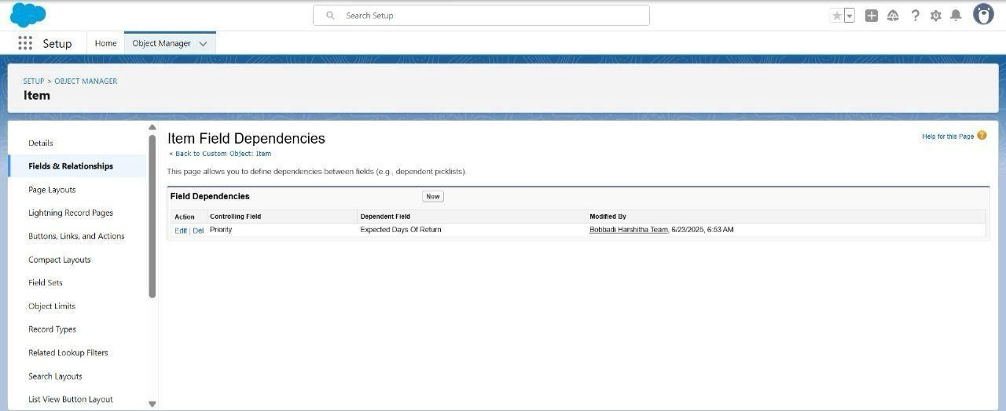

1. **Creation of Validation Rules**

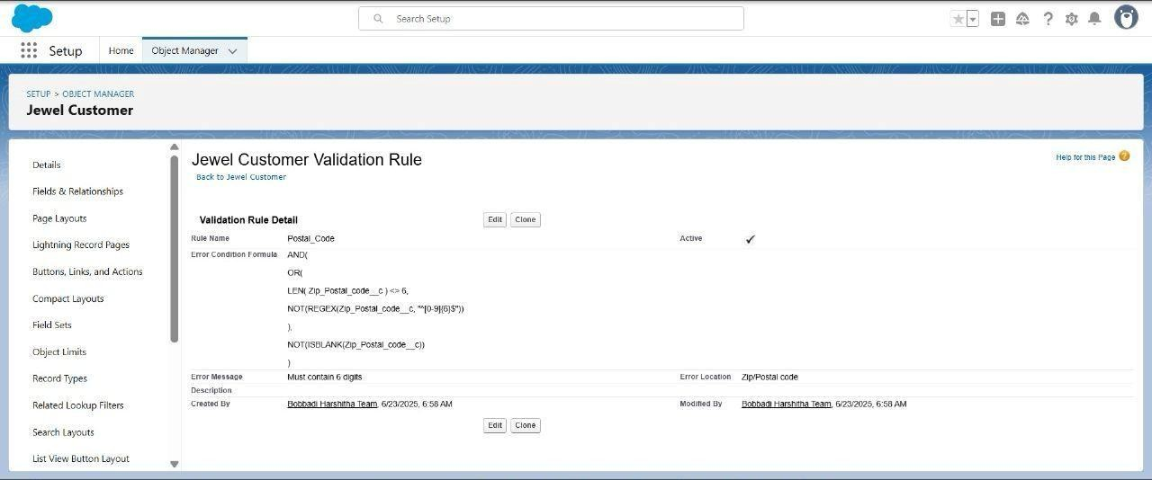

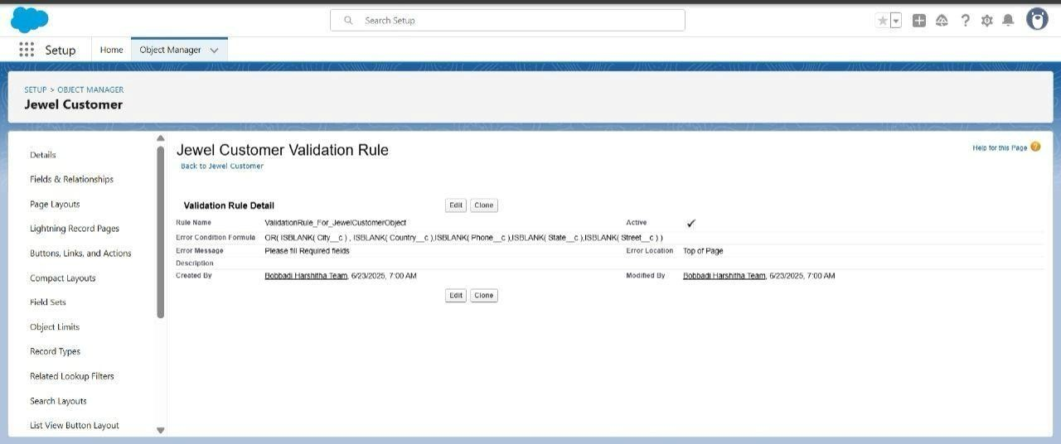

## 6.6 Creation of Profiles

We create the goldsmith profile and the worker profile

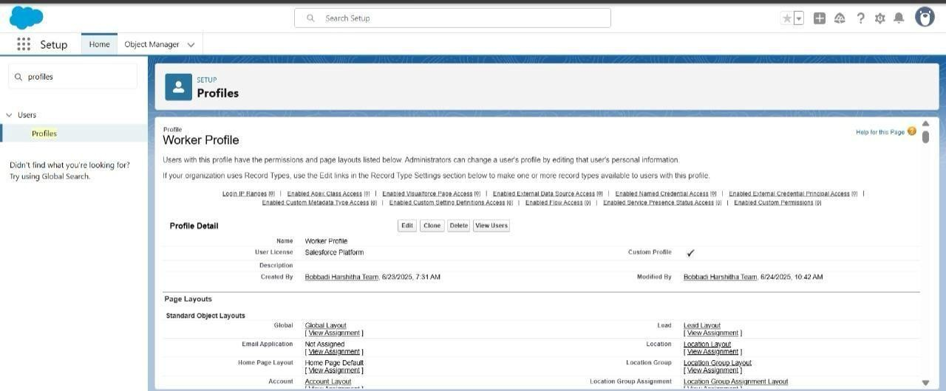

## 6.7 Creation of Roles

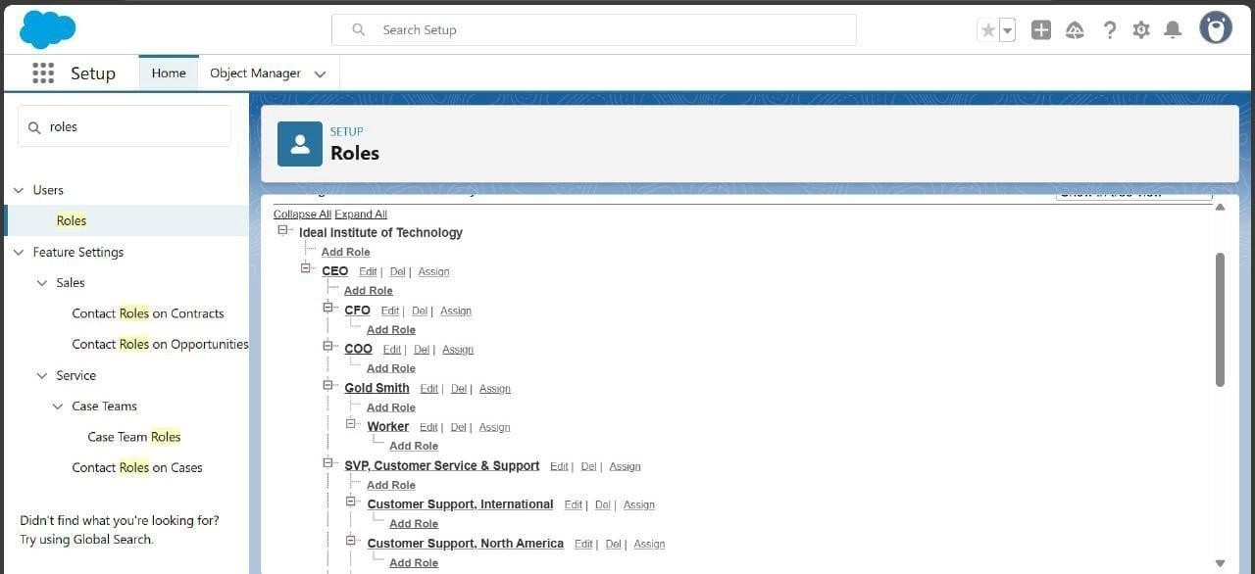

## 6.8 Creation of Users

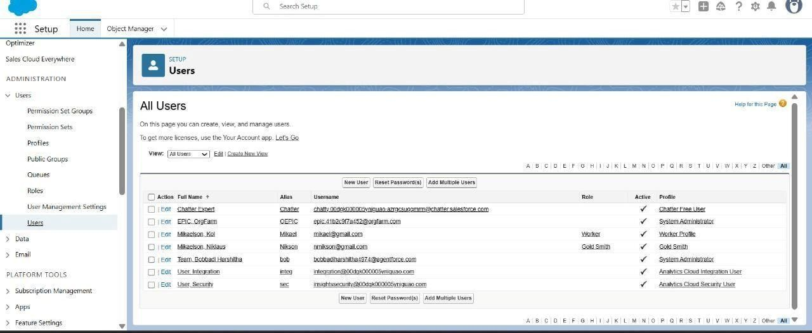

**6.9 Creation of Page Layouts**

We create the page layouts for gold and silver items

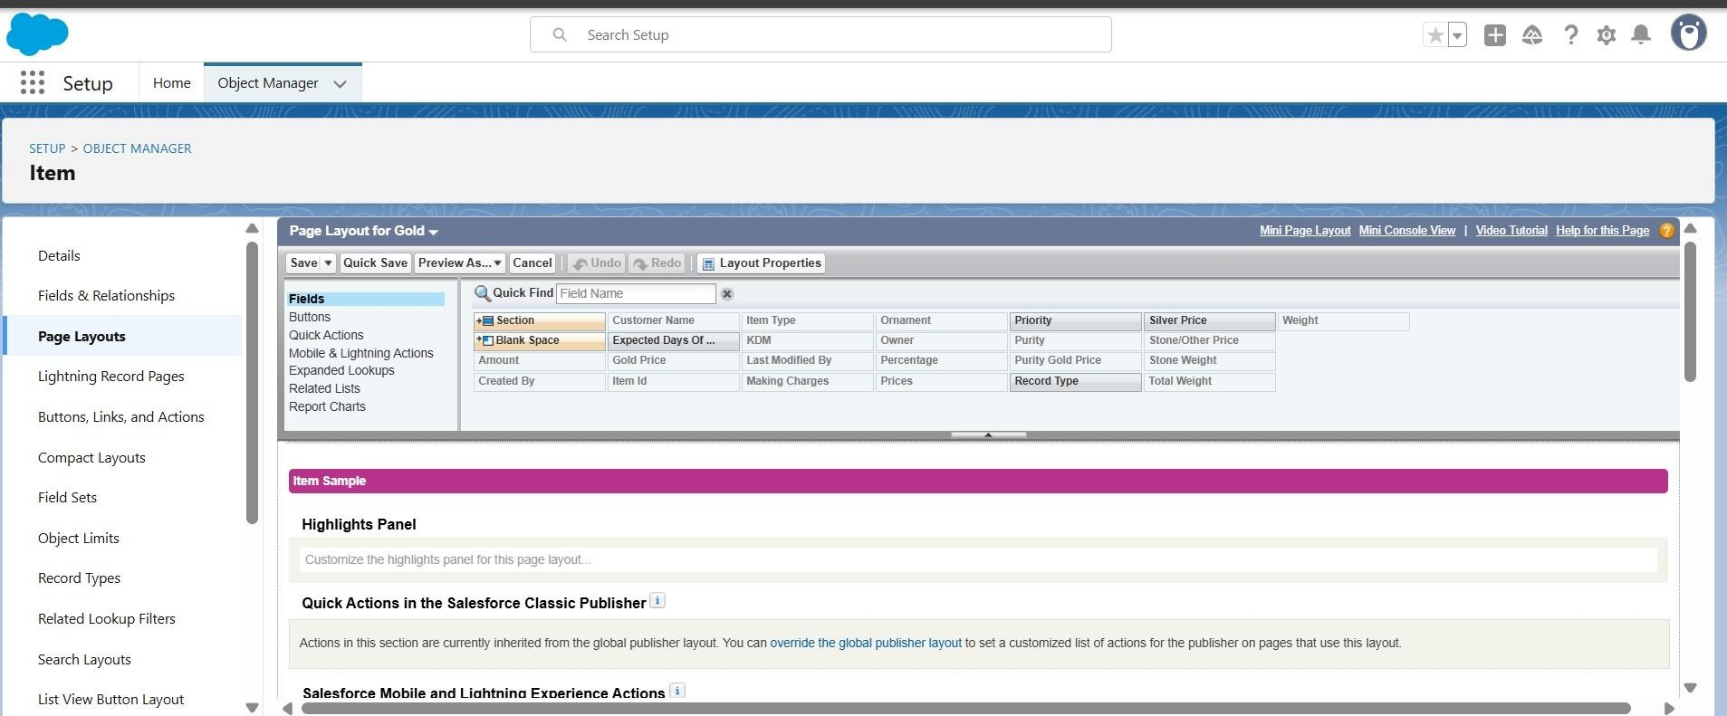

**6.10 Creation of Record Types**

We create the gold an silver records

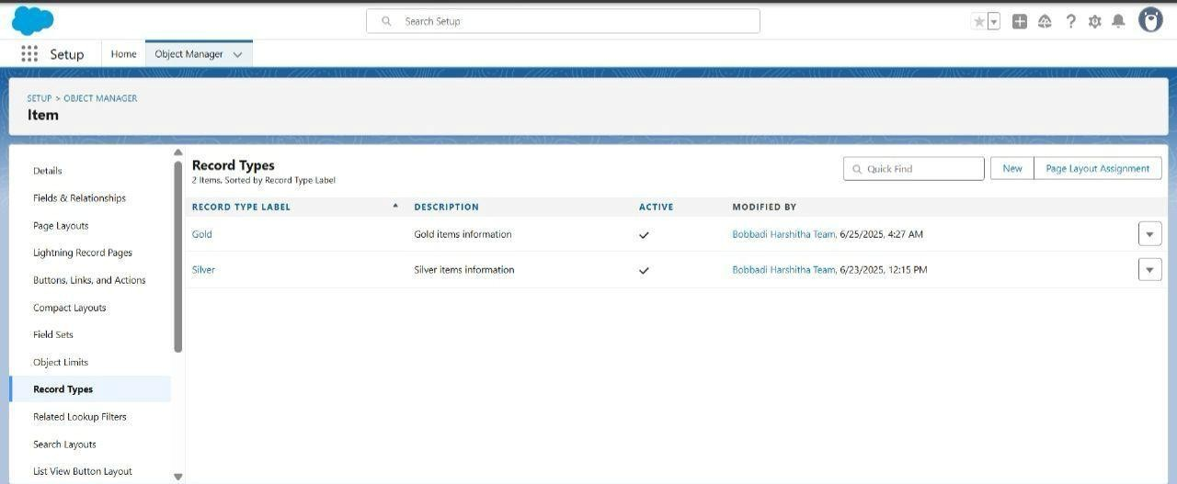

**6.11 Creation of Permission Sets**

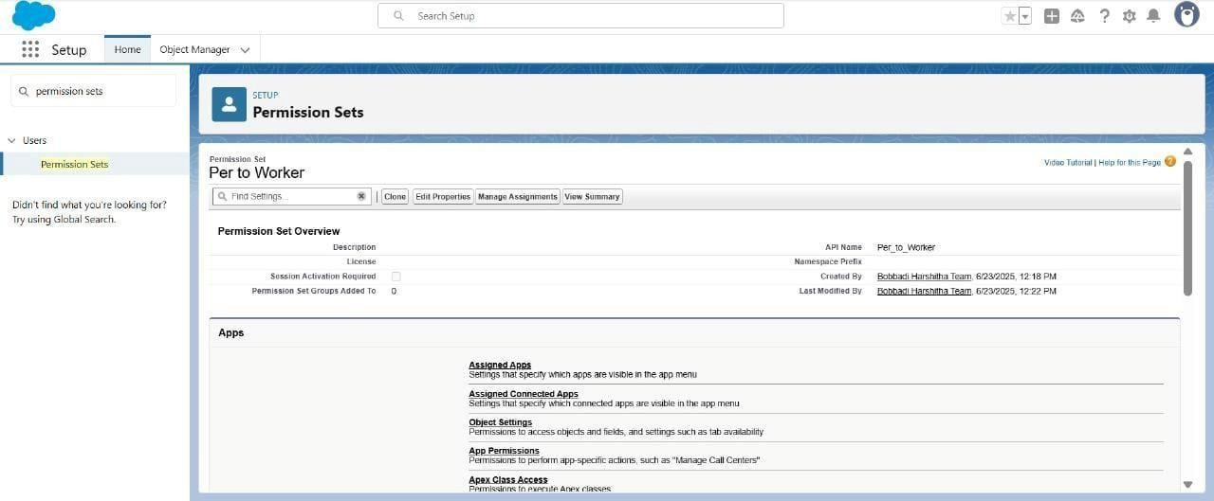

**6.12 Creation of Trigger**

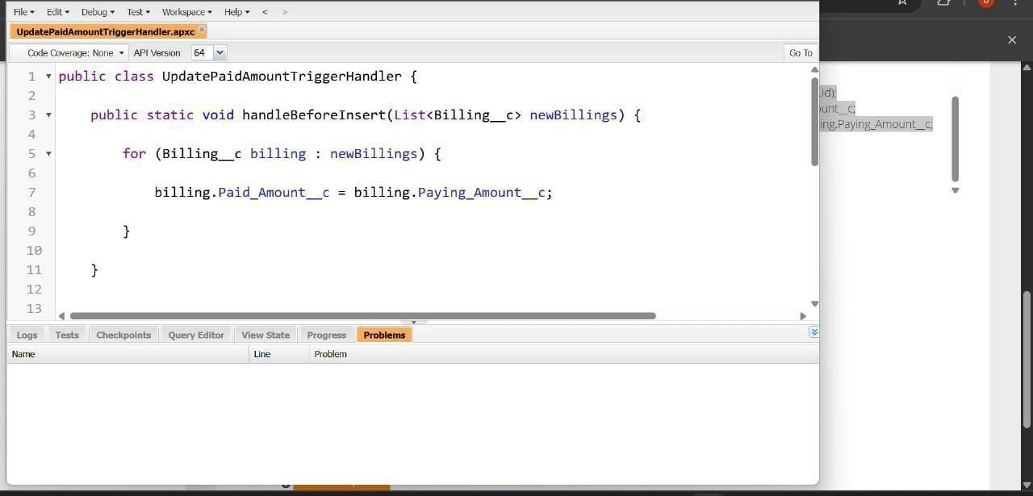

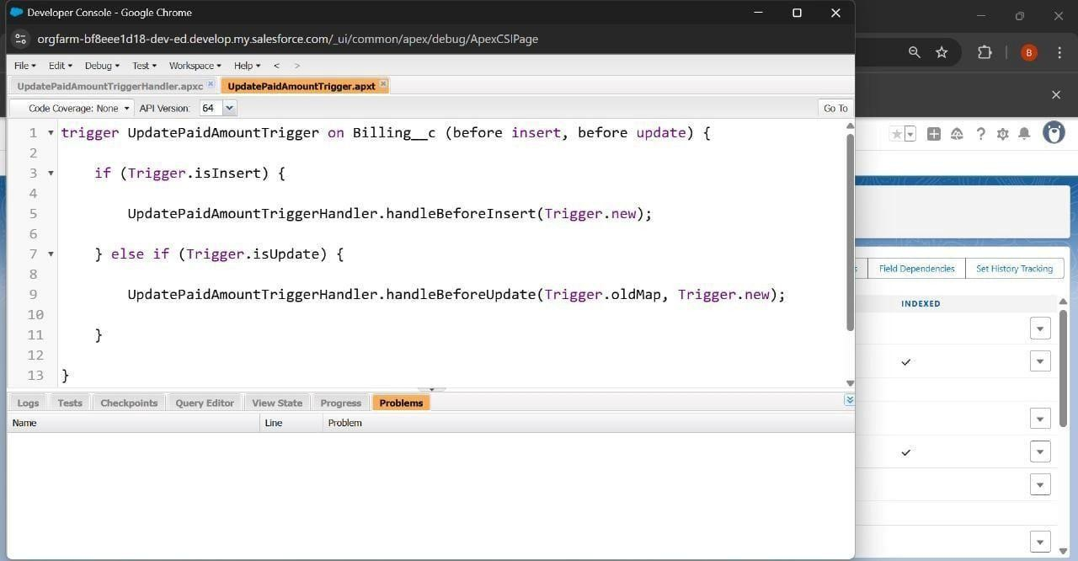

**6.13 Creation of User Adoption**

We create item,price,customer orders,jewel customers and billing

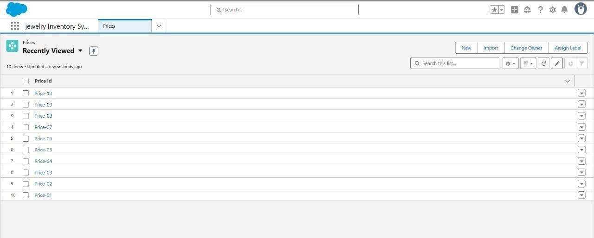

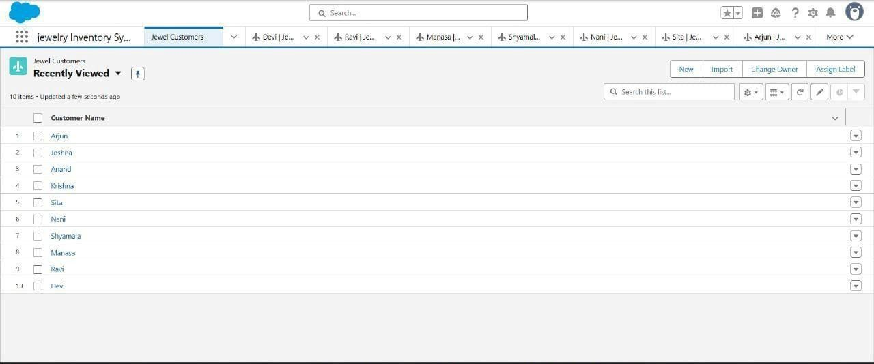

**6.14 Creation of Reports**

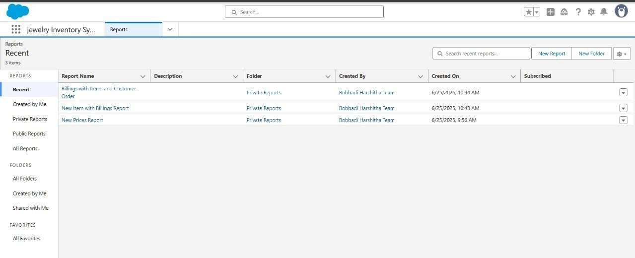

**6.15 Creation of Dashboards**

**Dashboard 1**

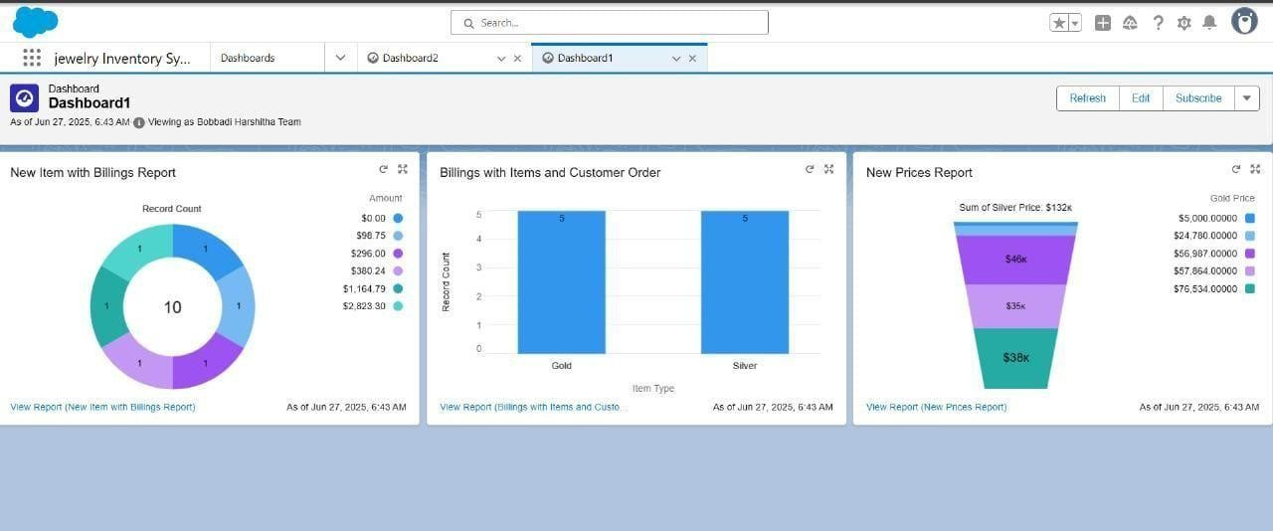

**Dashboard 2**

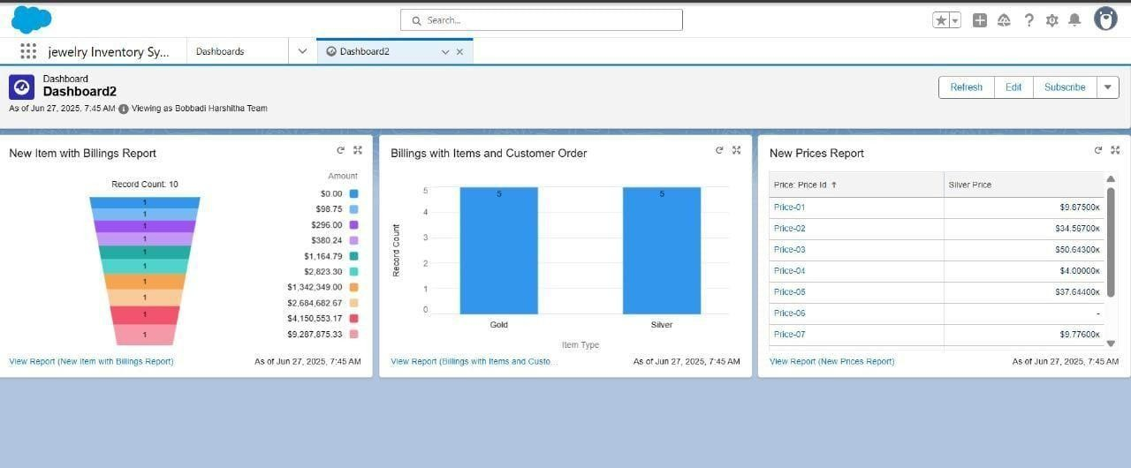

**6.16 Creation of Flows**

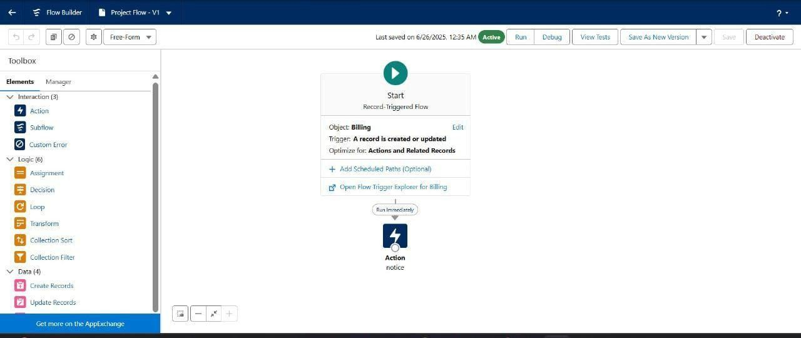

# 7. FUNCTIONAL AND PERFORMANCE TESTING

**Dashboard-1:**



**Performance Observations (Phase Testing) for Dashboard-1:**

1. **Accurate Data Visualization**

All three charts (donut, bar, funnel) rendered correctly with real-time values.

Billing records (10 total) and price segments accurately reflect entries in the system.

Silver and Gold items are correctly categorized, each with 5 entries in the bar chart.

1. **Functional Report Integration**

“View Report” links under each chart are working and redirect to detailed Salesforce reports, confirming backend connectivity and report mapping is functional.

1. **Pricing Tier Segmentation is Clear**

Funnel chart shows diverse price bands for Gold and Silver items (e.g., ₹5k to ₹76k).

Total Silver pricing is correctly summed up as ₹132k, indicating correct aggregation logic.

1. **UI Load Stability**

All dashboard components load without errors or latency during testing.

Visuals are responsive and easy to interpret for both technical and non-technical users.

1. **Equal Distribution Verification**

Bar chart confirms equal distribution of Gold and Silver billings (5 each), helpful for verifying consistency during sales testing.

1. **Test Pass Indicators**

No missing data points, broken charts, or incorrect values observed during this testing phase.

Dashboard ready for stakeholder review or user acceptance testing (UAT).

**objectives for the Jewelry Inventory System project using Salesforce CRM for Dashboard-1:**

1. **Improve Inventory and Billing Accuracy:**

Streamline the tracking of jewelry items, their pricing, and associated billing records to ensure real-time visibility and eliminate manual errors in stock and transaction management.

1. **Enhance Customer Order Management:**

Establish a seamless linkage between jewelry items and customer orders (Gold/Silver types),enabling faster processing, better customer service, and accurate historical records.

1. **Enable Data-Driven Business Decisions:**

Provide actionable insights through dynamic dashboards and reports that visualize billing trends, item-wise distribution, and pricing tiers—helping management make strategic inventory and pricing decisions.

**Dashboard-2:**



**Performance Observations from Dashboard-2:**

**1. New Item with Billings Report:**

10 items are billed, with amounts ranging from $0.00 to a high of $9,287,875.33.This wide range indicates possible inconsistencies or the presence of high-value custom items.One item is showing $0.00, which may point to a data error or a complimentary item.

1. **Billings by Item Type (Gold vs. Silver):**

Both Gold and Silver have 5 records each, indicating a balanced dataset.Good performance in terms of item-type categorization and data uniformity.

1. **New Prices Report:**

Prices for items like Price-03 and Price-05 are significantly high, exceeding $50k and $37k respectively.A few items (e.g., Price-06) are missing price data, which needs attention during testing **Project Objectives for Jewelry Inventory Management Dashboard -2(Phase Testing):**

1. **Track New Items with Billing Details:**

Objective is to visualize how new jewelry items are associated with billing values. Enabels monitoring of item value distribution, including extremely high and zero-value billings.

1. **Analyze Customer Orders by Item Type:**

Understand customer billing patterns for gold and silver items. Understand customer billing patterns for gold and silver items.

1. **Monitor and Update Jewelry Prices:**

View and compare the current silver prices for various jewelry products.Supports pricing strategy alignment with market rates.

# 8. RESULTS ( OUTPUT SCREENSHOTS)

**A. Automated Emails (using templates):**

* Stock Alert for Low Inventory

* Purchase Order Confirmation

* Sales Invoice Notification

* Inventory Replenishment Notification

* Daily Sales Summary

**B.Automated Workflows:**

* **Trigger-based validations**

**○** Auto-validate if stock is available before creating an invoice ○ Alert for duplicate product entries

**C. Approval Workflow Output:**

* **Product Addition Requests**

* 1. New products require manager approval before appearing in inventory

* **Stock Reorder Requests**

* 1. Approval triggered when reorder level is reached

* **Notifications**

* 1. In-app and email notifications sent for each approval or rejection

**Dashboards:**





**Reports:**

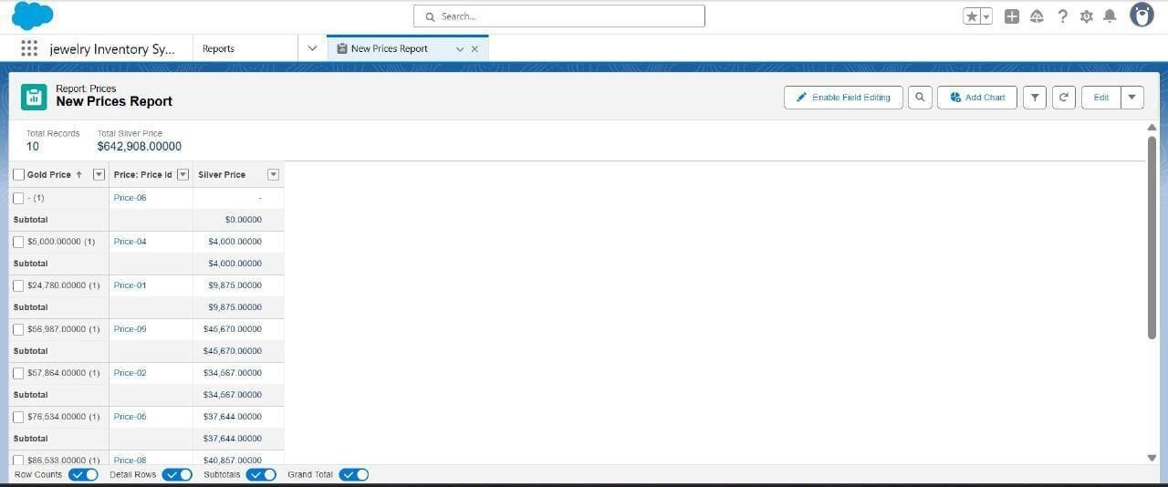

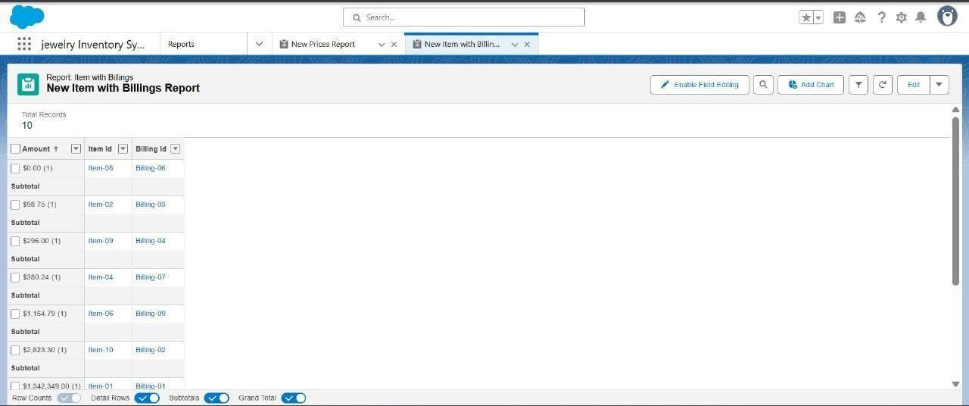

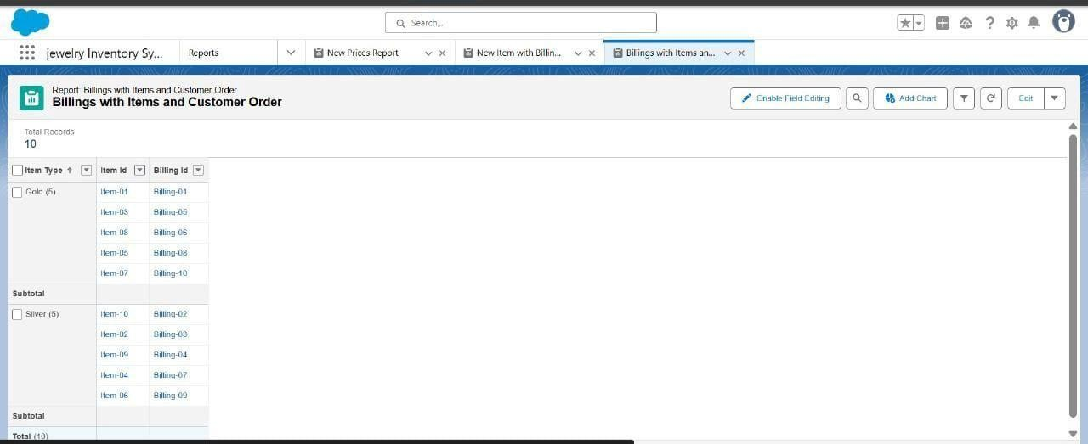

**Flows:**

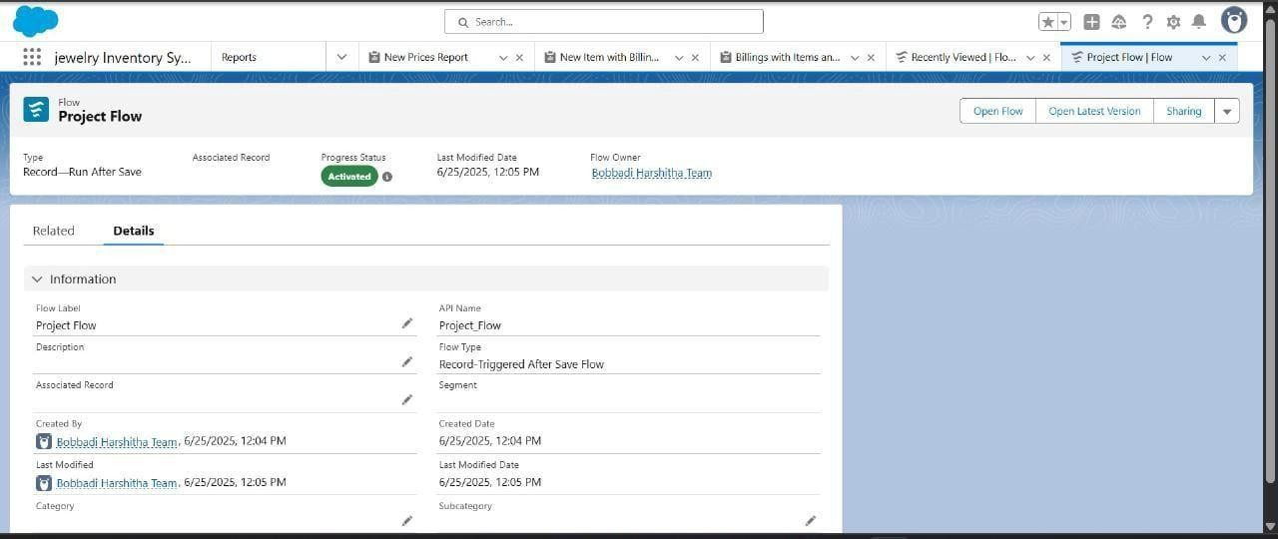



**Triggers:**

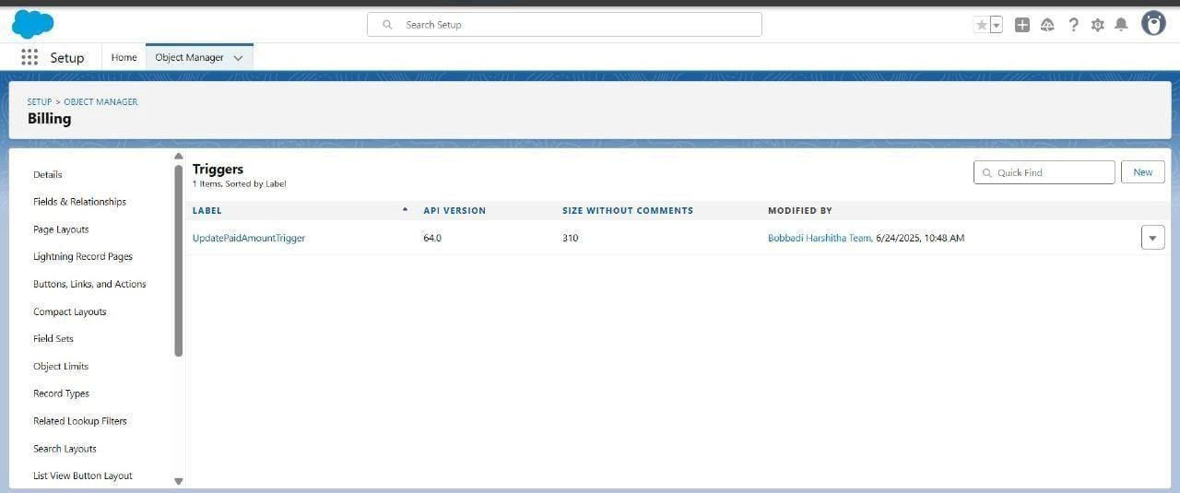

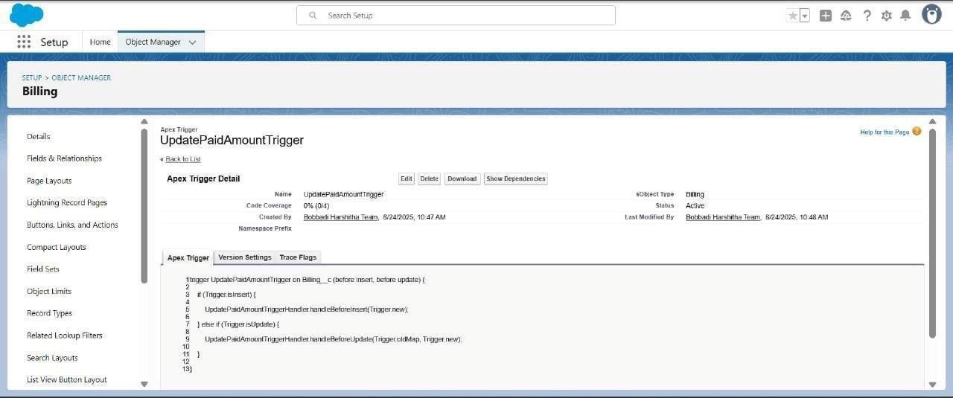

**9. ADVANTAGES AND DISADVANTAGES:**

**ADVANTAGES:**

**Automation Efficiency:**

All critical operations like billing, inventory updates, and notifications are automated via flows, reducing manual errors.

**Centralized Data Handling:**

Data is stored and managed in a centralized CRM system, making it easily accessible and modifiable.

**Real-Time Analytics:**

Dashboards and reports provide live updates on business performance, which helps in faster decision-making.

**User-Friendly UI:**

Salesforce Lightning provides a smooth and modern interface for all users.

**Scalability:**

The app can be expanded to handle more data and integrate with other business apps like payment gateways.

. **Customer Satisfaction:**

By streamlining the sales and service process, the application enhances the overall customer experience**.**

# DISADVANTAGES

**Learning Curve:**

New users may need training to understand Salesforce’s interface, objects, and flows.

**Customization Dependency:**

Some specific logic might require Apex development or third-party tools.

**Cost Factor:**

Scaling to a full enterprise-level Salesforce environment could be costly for small businesses.

**Admin Management:**

Role and permission setup must be carefully handled to ensure data security.

# 10. CONCLUSION

"In conclusion, the CRM Application for Jewel Management serves as a robust, cloud-based solution built using Salesforce. It brings digital transformation to traditional jewelry retailing by:

→ Streamlining operations with custom objects and flows

→ Improving business oversight with real-time dashboards

→ Automating repetitive tasks like billing and inventory updates

→ Enhancing data integrity and customer service

The project demonstrates how low-code tools like Salesforce Flow and Lightning App Builder can be used by developers to create enterprise-grade solutions. Our application is not only scalable and efficient but also provides a solid foundation for future business growth in the jewelry sector."

# 11. FUTURE SCOPE

"The current CRM application for Jewel Management lays a strong foundation for digital jewellery retail operations. However, the system can be further improved and extended in the following ways:

**Payment Gateway Integration:**

Integrate with online payment services such as Razorpay, PayPal, or Stripe to allow direct billing and payment within the CRM.

**SMS and WhatsApp Alerts:**

Enhance communication by integrating Twilio or other SMS APIs to send updates like order confirmations, billing alerts, or promotions.

**Mobile App Development:**

Extend the system using Salesforce Mobile SDK to create a dedicated mobile app for store owners and executives to manage inventory and billing on-the-go.

**Barcode Scanner Support:**

Enable barcode scanning through the mobile app or connected devices for faster item search and billing.

**AI-Based Recommendations:**

Use Salesforce Einstein to provide personalized recommendations to customers based on previous purchase history.

**Third-Party Integrations:**  Connect with accounting software like QuickBooks or Tally for autosyncing of billing and financial data.

**Multi-Store Management:**

Add support for multiple branches or stores to manage inventory separately but view consolidated dashboards.

**Customer Feedback System:**

Implement a feedback module to collect and analyse customer reviews, which can be visualized in reports.